|  |  |  |  |  |  |  |
| --- | --- | --- | --- | --- | --- | --- |
| Iteration | U(1,1) | U(1,2) | U(1,3) | U(2,1) | U(2,3) | U(3,1) |
| 0 | 0 | 0 | 0 | 0 | 0 | 0 |
| 1 | -0.04 | -0.04 | -0.04 | -0.04 | -0.04 | 0.68 |
| 2 | -0.076 | -0.076 | -0.076 | 0.44 | -0.076 | 0.74 |
| 3 | 0.26 | -0.11 | -0.11 | 0.57 | -0.11 | 0.79 |
| 4 | 0.40 | 0.13 | -0.14 | 0.63 | -0.14 | 0.80 |
| 5 | 0.46 | 0.27 | 0.03 | 0.65 | -0.17 | 0.81 |

|  |  |  |  |
| --- | --- | --- | --- |
| Iteration | Q(1,1,right) | Q(2,1,right) | Q(3,1,up) |
| 0 | 0 | 0 | 0 |
| 1 | -0.04 | -0.04 | 0.77 |
| 2 | -0.07 | 0.58 | 0.85 |
| 3 | 0.43 | 0.71 | 0.86 |
| 4 | 0.58 | 0.73 | 0.86 |
| 5 | 0.61 | 0.73 | 0.86 |
| 6 | 0.62 | 0.73 | 0.86 |
| 7 | 0.62 | 0.73 | 0.86 |

1. the wumpus smells the gold

= P(wumpus|the)*P(smells|wumpus)*P(the|smells)*P(gold|the)=

$$=\frac{8000}{8000+6000+2000}*\frac{5000}{5000+6000}*\frac{4000}{4000+2000}*\frac{2000}{2000+8000+6000}= \\ =0.5*\frac{5}{11}*\frac{2}{3}*0.125≈0.01893939≈0.02$$

1. the wumpus is dead

$$=P\left(wumpus | the\right)*P\left(is | wumpus\right)*P\left(dead | is\right)= \\ =\frac{8000}{8000+6000+2000}*\frac{6000}{6000+5000}*\frac{2000}{2000}=0.5*\frac{6}{11}*1≈0.2727≈0.27$$

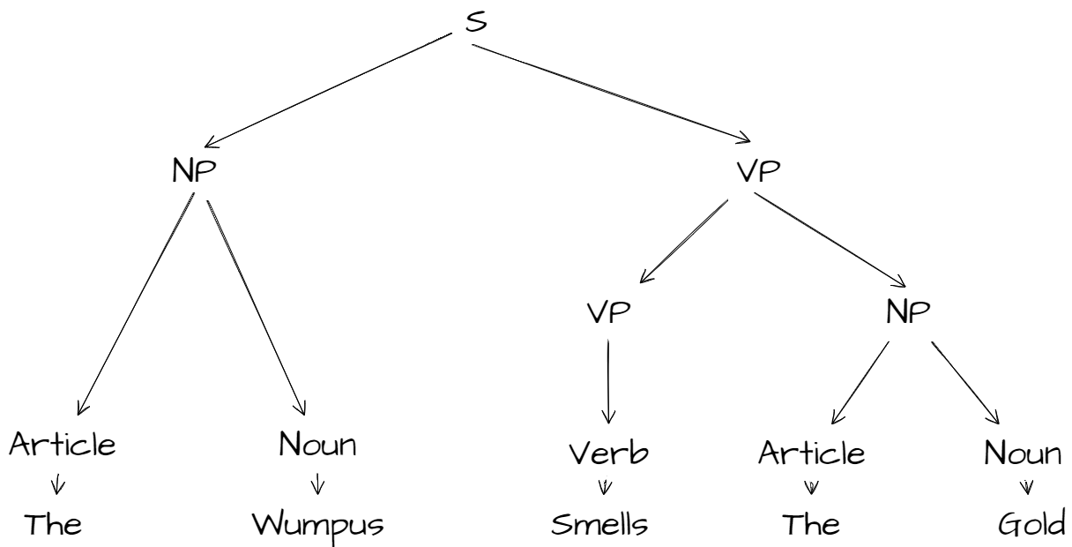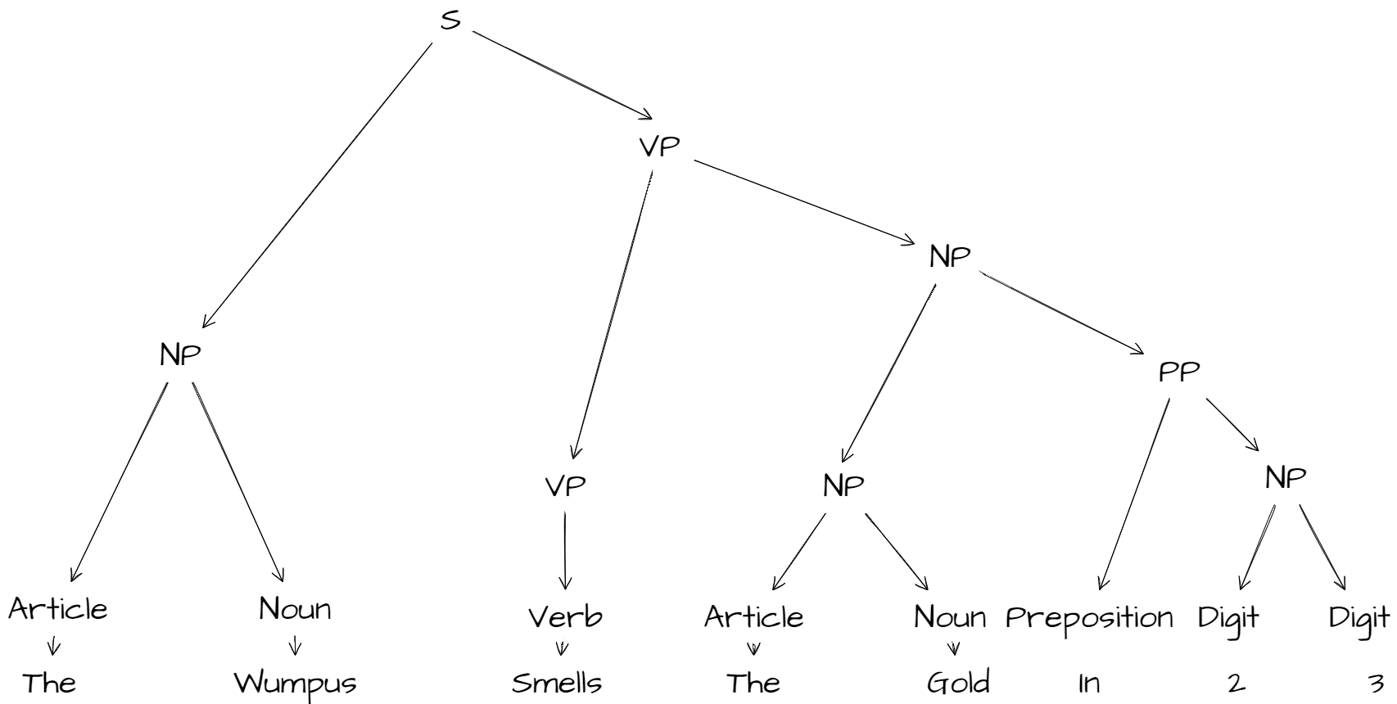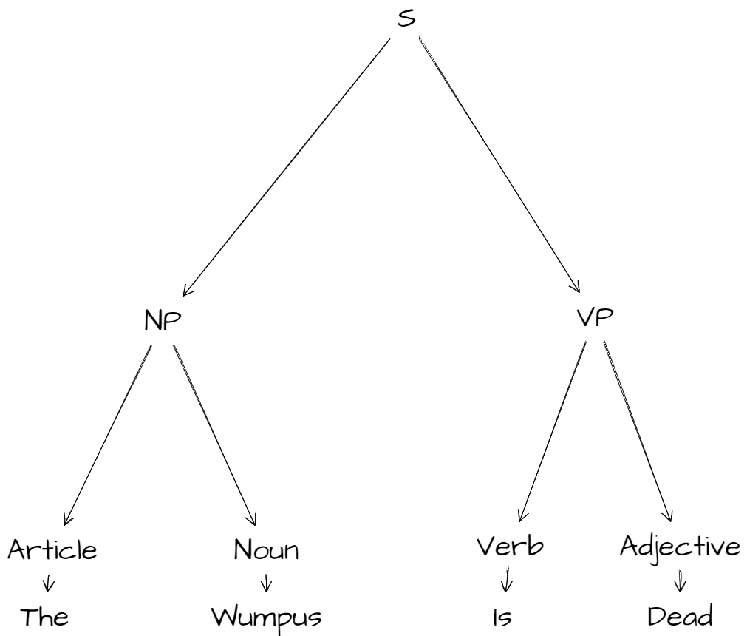

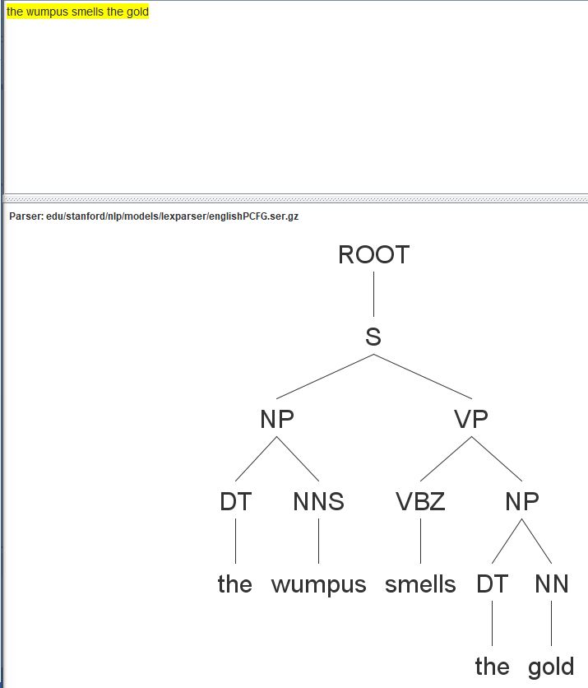

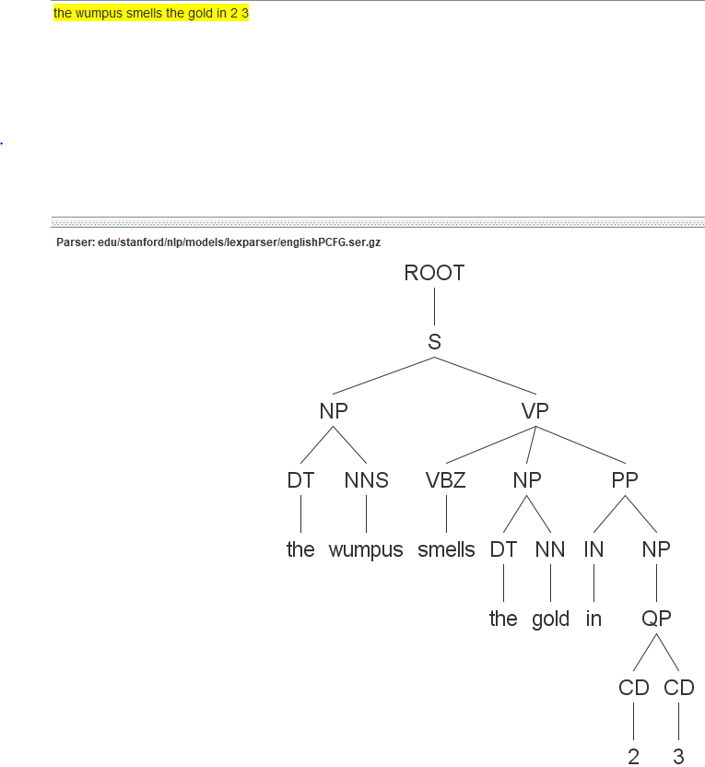

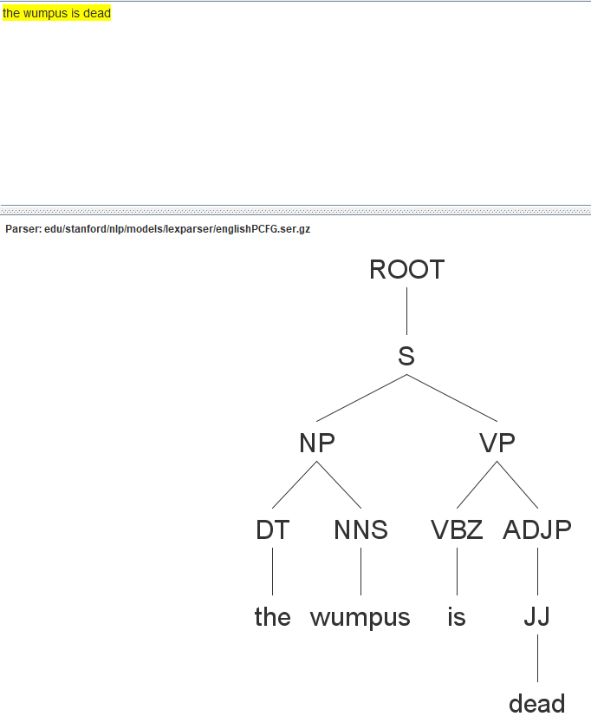

|  |  |  |  |  |  |  |
| --- | --- | --- | --- | --- | --- | --- |
| Iteration | U(1,1) | U(1,2) | U(1,3) | U(2,1) | U(2,3) | U(3,1) |
| 0 | 0 | 0 | 0 | 0 | 0 | 0 |
| 1 | -0.04 | -0.04 | -0.04 | -0.04 | -0.04 | 0.68 |
| 2 | -0.08 | -0.08 | -0.08 | 0.44 | -0.08 | 0.74 |
| 3 | 0.26 | -0.11 | -0.11 | 0.57 | -0.11 | 0.79 |
| 4 | 0.38 | 0.13 | -0.14 | 0.63 | -0.14 | 0.80 |
| 5 | 0.46 | 0.26 | 0.03 | 0.65 | -0.17 | 0.81 |
| 6 | 0.49 | 0.34 | 0.14 | 0.66 | -0.05 | 0.81 |
| 7 | 0.51 | 0.37 | 0.21 | 0.66 | 0.05 | 0.81 |
| 8 | 0.51 | 0.39 | 0.25 | 0.66 | 0.12 | 0.81 |
| 9 | 0.52 | 0.40 | 0.27 | 0.66 | 0.16 | 0.81 |
| 10 | 0.52 | 0.41 | 0.29 | 0.66 | 0.18 | 0.81 |
| 11 | 0.52 | 0.41 | 0.30 | 0.66 | 0.20 | 0.81 |
| **12** | **0.52** | **0.41** | **0.30** | **0.66** | **0.21** | **0.81** |
| 13 | 0.52 | 0.41 | 0.30 | 0.66 | 0.21 | 0.81 |

As we can see, values converged after 12 iterations (for 13th iteration there’s no change in values).